Alerts

Deposits

Average Balance

Process:

For every deposit account in a relationship (grouped by household number), the described steps are followed. Later, we will walk through a manual aggregation on the household level and the associated Daily Deposit Update excel file will be helpful for tying this all together.

1. Take notemtdavgbal (average monthly balance snapshot at the end of each month) for a rolling period of n months.
   1. The variable ‘n’ gets set to 3 months and 12 months to create separate dataframes that can be used for rolling balances.
   2. Shown below is the 3 month dataframe for an account number that we are validating

* 1. To validate, we can to Insight (COCC) and search for that deposit account by account number
     1. Navigate to Inquiries -> Average Balance Inquiry

* 1. The rolling average is on completed months, so you would look at the run date of the alerts file and the trailing window of months would start at current month minus 1.
     1. For example, during this validation on 07/14/2025, the trailing 3 months would be for April-June.
     2. See the accompanied screenshots from COCC to recreate this with the exact same numbers

1. Next, we take an average of these monthly avg balances

In COCC, this could’ve been done in 1 step by feeding in the full date range.

(04-01-2025 to 06-30-2025)

Moving to the daily deposit file, we can see this is the 3 month average balance listed for 1 of the accounts and then this is summed up on the household level to get the total 3 month relationship balance.

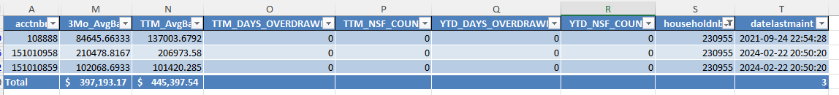

This goes directly into the Alerts flag for deposit changes.

The Days Overdrawn is computed the same way where we roll up on the household level.

1. Instead of Average Balance Inquiry, you can visit Additional -> Statistics and find the ‘DOD’ (Days Overdrawn) and this is computed on the account level and then rolled up.

Switching to an account number where # of Overdrafts > 0, here what the data looks like in the alerts data pipeline.

In COCC:

Note that in COCC, the statics are stored with Month and Year, so we make all statics as of the beginning of the month

* If there was an overdraft in May 2025, this becomes 05/01/2025 as date of occurrence.

The start date/end dates for statistics are shown below, for a run for today.

The logic:

* The start date is whatever the current month is, go back 1 year and take the first of the month
* Any statistics that occur during that range will be aggregated on the account level and then the household level.

By that logic, we can see how we’d get exactly 19 by looking at this date range from the COCC view:

Since the production codebase and business logic stays the same, different data flowing through the same data pipeline will apply the same steps and create deterministic & repeatable results. Any changes that need to be made will be tracked in version control and discussed with business line before becoming effective.

If you have any questions, please reach out to BI dept.

Chad Doorley, 2025-07-14